Haskell Question Set 2
1) Find the length of your name.
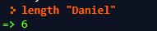

2) Check if a word is a palindrome with minimum effort (basically zero
effort).
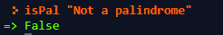

3) Write a function which given any word will calculate the second half of
the word. ie: computer -> uter. This is tricky, because / returns decimals
now. Use the `quot` function to do integer division.
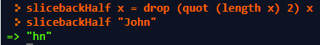

4) Write a function which given any word will calculate the first half of the
word. ie: computer -> comp.
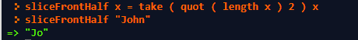

5) Write a function which given two separate lists returns the largest value
of the two lists.
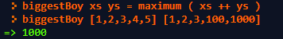

6) Write a function which takes a list and two parameters and returns true if
both of those parameters are in the given list.


7) Calculate how many symbols are from 'A' (uppercase A)to lowercase 'z'
(more than 52).

8) Calculate all the numbers from 100 to 0 by -1s. 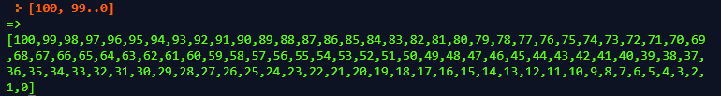
9) Calculate all the letters from 'A' to 'Z' but skip every other letter. 
10) Without using any numeric calculations (division or multiplication),
calculate the number of nickels it would take until you had one million
dollars.
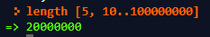
11) Grab the first 100 even numbers starting from 0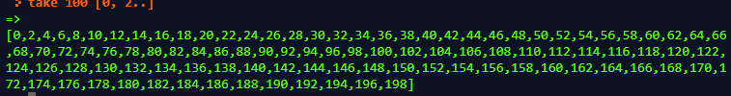
12) Write a function that given a starting value and a number x returns the
first x even numbers starting from the starting value. ie: firstXEven 52 4 -
> [52, 54, 56, 58].
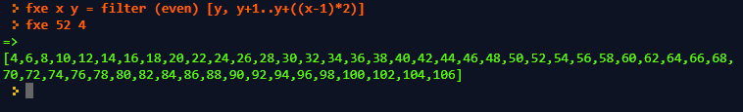

13) Write a function that given a String as a cryptography key and a number
for the number, x, of items you want from the key will return the first x
items in the repeated key. ie: cryptKey "abc" 8 -> "abcabcab"

14) Write a function that given a String and a number will return that many
copies of the String. ie: copyString "meow" 5 -> "meowmeowmeowmeowmeow"
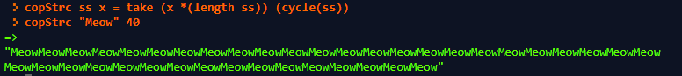
15) Write a function that given a String and a number will return that many
copies of the String but separated by a space. ie: copyString "meow" 5 ->
"meow meow meow meow meow"
16) Why does every if need an else?
In order to account for possible cases that do not fit the condition

